Supplementary Material for High-Throughput and Low-Latency DrDoS Detection Using Quantized ONNX Models

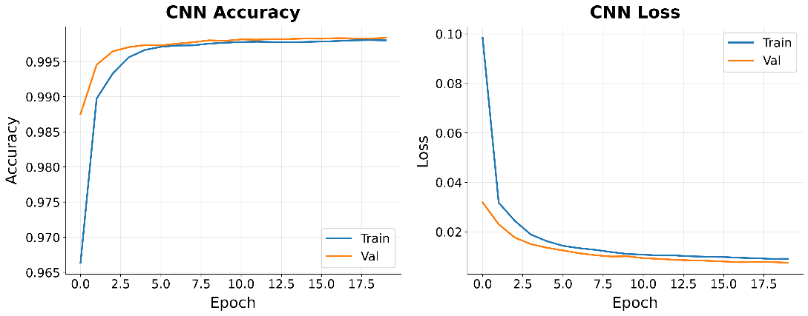
Figure S1: Validation-Training Loss and Accuracy Graphs for the CNN Model
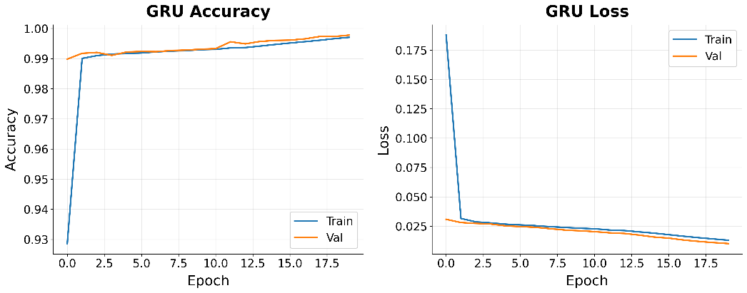
Figure S2: Validation-Training Loss and Accuracy Graphs for the GRU Model
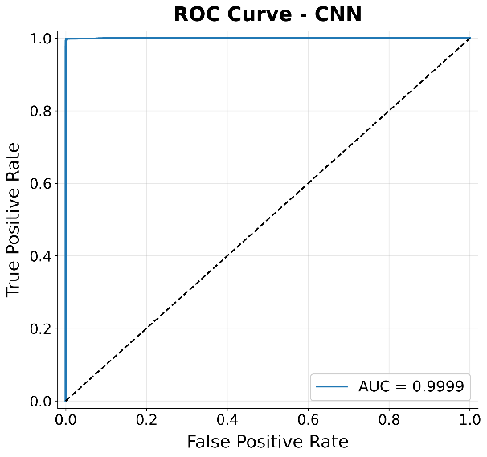
Figure S3: Test ROC Curve for the CNN Model
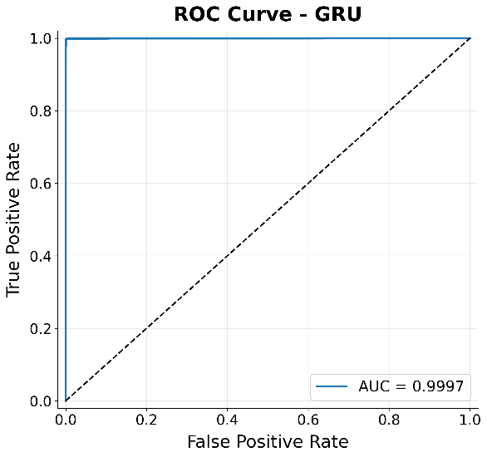
Figure S4: Test ROC Curve for the GRU Model
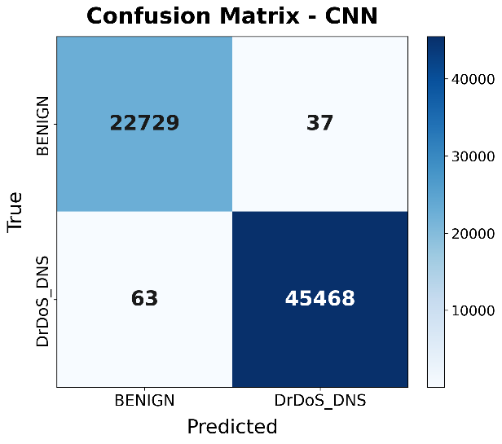
Figure S5: Confusion Matrix for the CNN Model
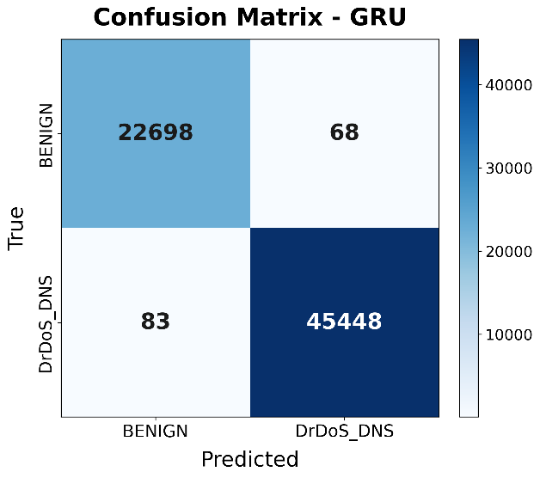
Figure S6: Confusion Matrix for the GRU Model
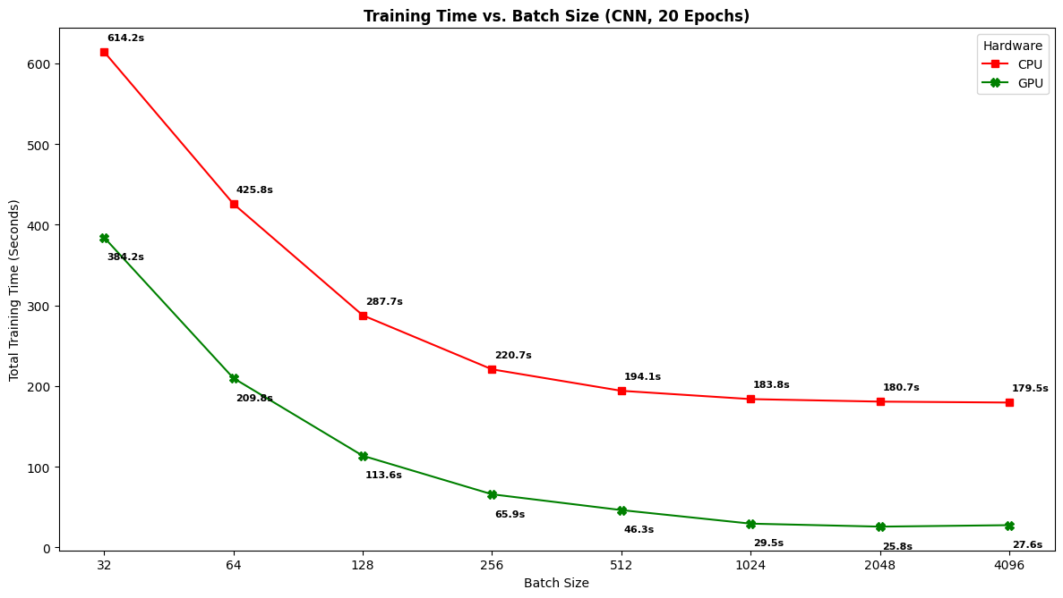
Figure S7: Training Time vs Batch Size (CNN)
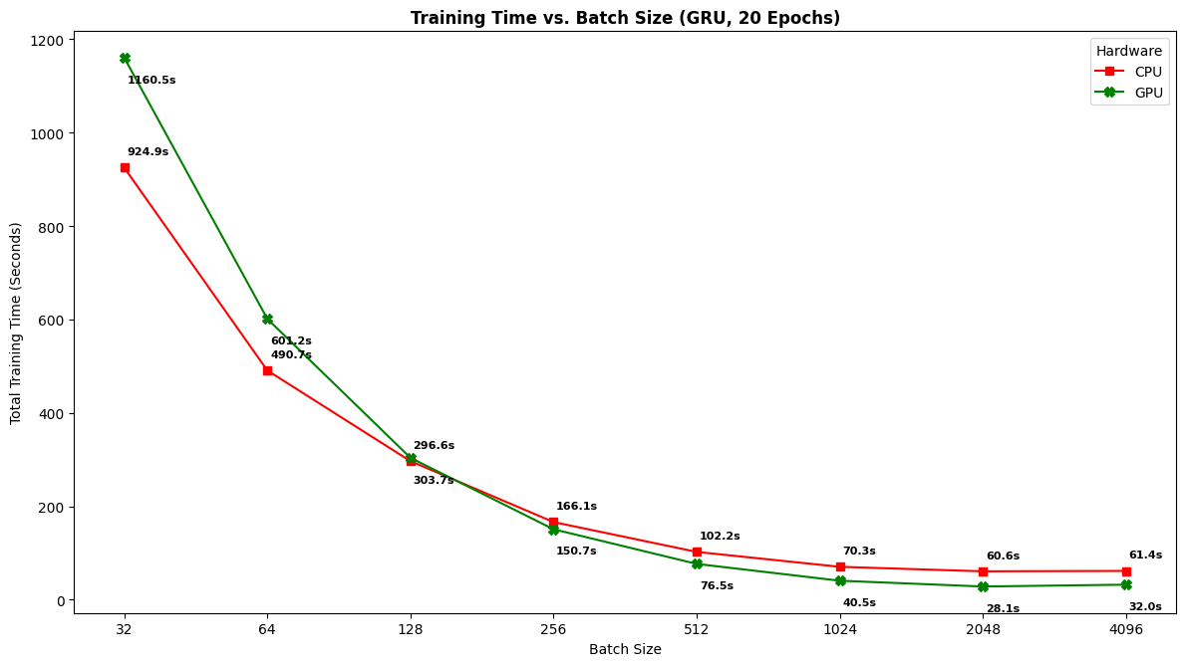
Figure S8: Training Time vs Batch Size (GRU)
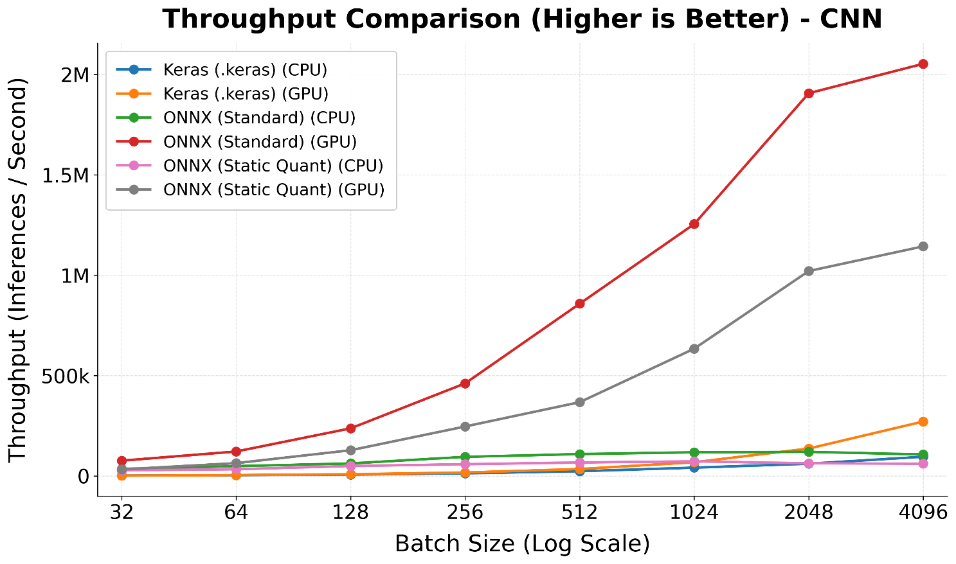
Figure S9: Throughput vs Batch Size (CNN)
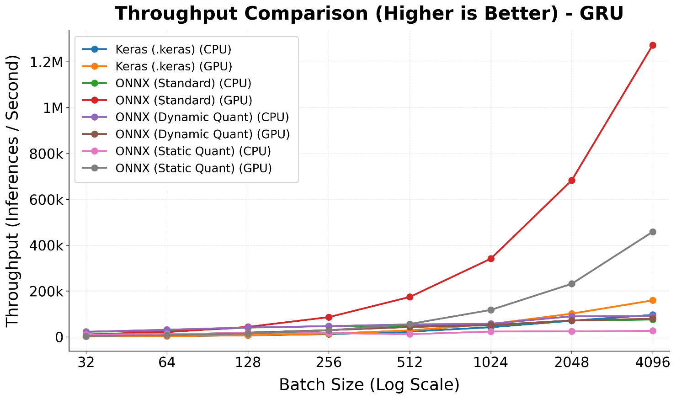
Figure S10: Throughput vs Batch Size (GRU)
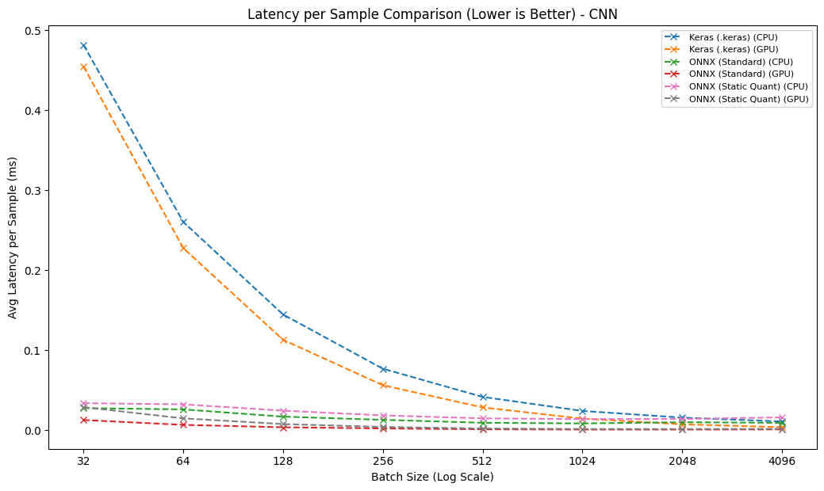
Figure S11: Latency vs Batch Size (CNN)
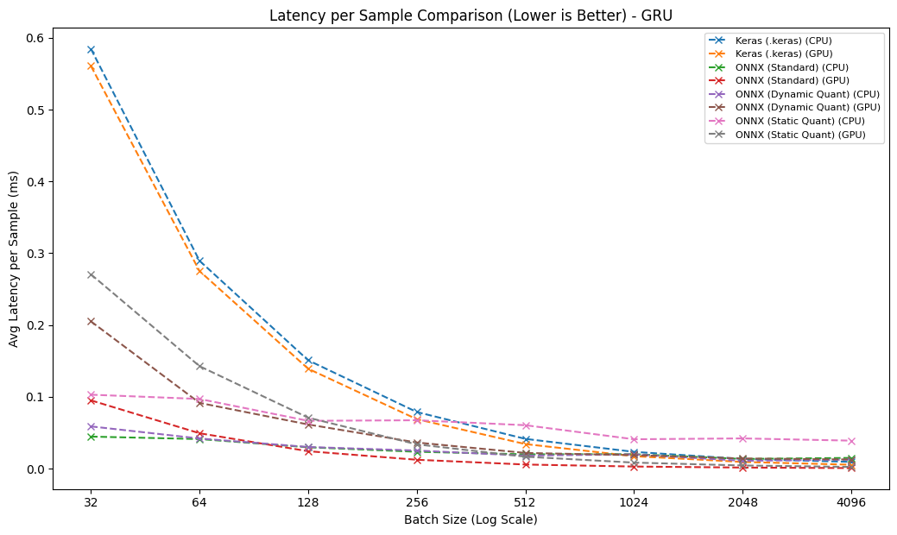
Figure S12: Latency vs Batch Size (GRU)
Table S1: CNN Model Comparison Summary.
Model | Environment | Inference Time (µs) | File size (MB)
Keras | CPU | 10.7489 | 0.7086
Keras | GPU | 3.5619 | 0.7086
ONNX | CPU | 8.2803 | 0.226
ONNX | GPU | 0.5917 | 0.226
Static Quantized ONNX | CPU | 13.7391 | 0.1056
Static Quantized ONNX | GPU | 1.2097 | 0.1056

Table S2: GRU Model Comparison Summary.
Model | Environment | Inference Time (µs) | File size (MB)
Keras | CPU | 9.3467 | 0.556
Keras | GPU | 5.3923 | 0.556
ONNX | CPU | 13.4195 | 0.2625
ONNX | GPU | 0.7397 | 0.2625
Dynamic Quantized ONNX | CPU | 10.8018 | 0.2534
Dynamic Quantized ONNX | GPU | 12.6615 | 0.2534
Static Quantized ONNX | CPU | 38.9413 | 0.7065
Static Quantized ONNX | GPU | 2.3361 | 0.7065

LIBRARY VERSIONS (reproducibility)
- python : 3.12.13
- platform : Linux-6.6.122+-x86_64-with-glibc2.35
- numpy : 2.0.2
- pandas : 2.2.2
- scikit_learn : 1.6.1
- scipy : 1.16.3
- matplotlib : 3.10.0
- seaborn : 0.13.2
- tensorflow : 2.20.0
- keras : 3.13.2
- onnx : 1.22.0
- tf2onnx : 1.17.0
- onnxsim : 0.6.5
- protobuf : 5.29.6
- onnxruntime_gpu (GPU inference) : 1.20.1
- onnxruntime_cpu (CPU inference / CNN dynamic-quant): 1.27.0
- cuda : 12.5.1
- cudnn : 9
- gpu : A100 [PhysicalDevice(name='/physical_device:GPU:0', device_type='GPU')]
- ONNX Runtime: GPU=onnxruntime-gpu 1.20.1 | CPU=onnxruntime 1.27.0 (iki ayri faz)
- Random seeds: global=42 | split=42 | downsample=27 | variance=1000-1029

All experiments were conducted on Google Colab using an NVIDIA A100 GPU (Linux 6.6.122, x86_64, glibc 2.35; CUDA 12.5.1, cuDNN 9). The software stack was: Python 3.12.13, TensorFlow 2.20.0 (Keras 3.13.2), NumPy 2.0.2, pandas 2.2.2, scikit-learn 1.6.1, SciPy 1.16.3, matplotlib 3.10.0, seaborn 0.13.2, ONNX 1.22.0, tf2onnx 1.17.0, onnxsim 0.6.5, and protobuf 5.29.6. ONNX inference was evaluated with two ONNX Runtime builds in separate sessions: ONNX Runtime-GPU 1.20.1 for GPU benchmarks—executed in a TensorFlow-free session to avoid GPU-memory contention—and ONNX Runtime 1.27.0 (CPU build) for CPU benchmarks, including the CNN dynamic-quantized model whose ConvInteger operator is implemented only in the CPU build. All random seeds were fixed to ensure determinism: a global seed of 42 (NumPy, Python random, and TensorFlow), random_state = 42 for the stratified train/test split, random_state = 27 for downsampling.

